Programming Assignment Unit 2

An Assignment submitted in partial fulfillment of the requirements for the degree of
Bachelor of Science
in
Computer Science

CS 2203 – Databases
Term 1 - 2025
University of The People

September 19, 2024

Programming Assignment Unit 1
Entities and attributes
- Product: Represents the various items sold by the e-commerce company. Its attributes include ProductID (Primary Key), ProductName, ProductPrice, ProductCategory, and ProductDescription.
- Customer: Represents users who purchase products. Its attributes include CustomerID (Primary Key), CustomerName, CustomerEmail, CustomerPhone, and ShippingAddress.
- Order: Represents customer orders. Its attributes include OrderID (Primary Key), OrderDate, TotalAmount, and CustomerID (Foreign Key from Customer).
- Inventory: Represents stock availability for products. Its attributes include InventoryID (Primary Key), ProductID (Foreign Key from Product), StockQuantity, and WarehouseLocation.
Relationships between entities
- Customer places order: A customer can place one or many orders (1-to-many relationship).
- Order contains product: An order can contain one or many products, and a product can belong to multiple orders (many-to-many relationship). We would use a junction table OrderDetails for this relationship.
- Inventory tracks product: Each product has an associated inventory record (1-to-1 relationship).
Translating Entities into Tables
- Product Table:
Column Name | Data Type | Constraints
ProductID | INT | PRIMARY KEY
ProductName | VARCHAR(255) | NOT NULL
ProductPrice | DECIMAL(10,2) | NOT NULL
ProductCategory | VARCHAR(100) | NOT NULL
ProductDescription | TEXT
- Customer Table:
Column Name | Data Type | Constraints
CustomerID | INT | PRIMARY KEY
CustomerName | VARCHAR(255) | NOT NULL
CustomerEmail | VARCHAR(255) | NOT NULL, UNIQUE
CustomerPhone | VARCHAR(15)
ShippingAddress | TEXT
- Order Table:
Column Name | Data Type | Constraints
OrderID | INT | PRIMARY KEY
OrderDate | DATETIME | NOT NULL
TotalAmount | DECIMAL(10,2) | NOT NULL
CustomerID | INT | FOREIGN KEY (CustomerID) REFERENCES Customer(CustomerID)

- Inventory Table:
Column Name | Data Type | Constraints
InventoryID | INT | PRIMARY KEY
ProductID | INT | FOREIGN KEY (ProductID) REFERENCES Product(ProductID)
StockQuantity | INT | NOT NULL
WarehouseLocation | VARCHAR(255)

- OrderDetails Table (For many-to-many relationship between Order and Product):
Column Name | Data Type | Constraints
OrderID | INT | FOREIGN KEY (OrderID) REFERENCES Order(OrderID)
ProductID | INT | FOREIGN KEY (ProductID) REFERENCES Product(ProductID)
Quantity | INT | NOT NULL
PriceAtTime | DECIMAL(10,2) | NOT NULL
PRIMARY KEY (OrderID, ProductID)

ER Diagram
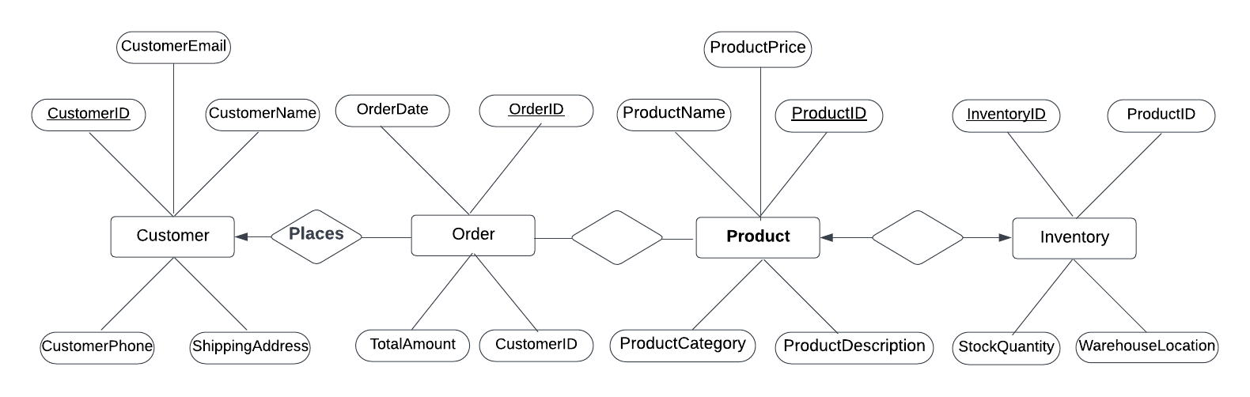

Differences between conceptual and physical design
Conceptual design focuses on understanding the business requirements and creating a high-level design that describes the data and its relationships, without considering how it will be stored or managed. For example, it defines what data is needed but doesn’t specify database storage structures or indexing methods. However, physical design focuses on creating a detailed design that specifies how the data will be stored, managed, and accessed in the database. For instance, it would involve deciding on indexing strategies for quicker access to inventory or orders in the database.

Reference
Vidhya, V., Jeyaram, G., & Ishwarya, K. (2016). Database management systems. Alpha Science International.

